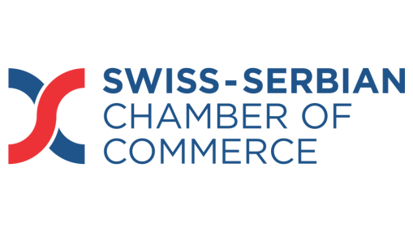
AGENDA
THE SWISS CHEESE FONDUE PARTY
Wednesday, February 25th, 2015
19.00 - 19.30 Gatherings of guests

19.30 - 19.35 Welcoming Speech
Mr. Ansgar Bornemann, CEO of ‘’Nestlé Adriatic’’ and SSCC president
- Welcoming address on behalf of the Swiss-Serbian Chamber of Commerce;

- Donation party: supporting young talents;

- Beneficiary: the music school „Mokranjac”, the oldest musical institution in Serbia.

19.35 - 19.40 Guest of Honor
H.E. Mr. Jean-Daniel Ruch, Ambassador of Switzerland to Serbia

19.40 - 19.45 About the music school ‘’Mokranjac’’

Mr. Miloš Trajković, Director of the music school „Mokranjac“

- History of the school and its success stories;

- Current situation and need for support.

19.45 - 20.00 Music harp performance by talented ‘ ’Mokranjac’’ students:

- Ms. Nadja Dornjik, and

- Mr. Marko Brkic
20.00 – 22.00 Fondue dinner/Cocktail - quartet background music

