THE GOVERNMENT'S PRIORITY: FIGHT AGAINST GRAY ECONOMY,
27/07/2014 - 15:16
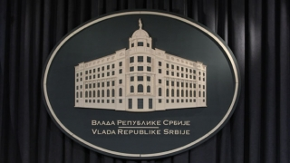

Fight against gray economy is one of the Government’s priorities, for which reason the latest data on the growth of tax revenues come as great news since they show that in Serbia illegal market of petroleum products is being successfully combated.
The highest tax revenues since the beginning of the year were achieved in June and amounted to 80.6 billion, and they considerably resulted from collection of excise taxes, which amounted to 25.6 billion.
Increased fuel consumption shows that the method of fuel marking, which was initiated by the previous Ministry of Energy, Development and Environmental Protection, reached its goal as early as five months later and led to more efficient fuel quality control and restriction of illegal fuel market.
In spite of slowdown in economic activities and catastrophic floods in Serbia in the period from February to June 2014., recorded growth in sale of diesel and gasoline was 13.9 and 18 percent, respectively. Fighting against black market during the last five months has led to four billion RSD more money in the budget than at the same time in 2013.
If this trend continues, by the end of the year, only as the result of Fuel Marking, income from excise taxes could be increased by around 60 million euros, or 20 million more than the original estimates.
Only from introduction of Fuel Marking and the sale of liquefied petroleum gas, which is expected to begin on September 1, the state annual income would be up to 100 million EUR higher than from trade of petroleum products.

Deputy Prime Minister

